Experiment No-07
Synthesis of a 32-bit Pipelined Adder using RTL Compiler / Genus Compiler

1.1 Objectives
The main objectives of this experiment are summarized as:
- To simulate and verify an 8-stage pipelined 32-bit adder in NCLaunch/SimVision before proceeding to synthesis.
- To understand pipelining as a technique for shortening the critical path of a datapath circuit, at the cost of added latency.
- To write timing constraints (SDC) for the design and use them to guide synthesis.
- To use Cadence RTL Compiler (rc) to synthesize the pipelined adder, and to examine its synthesis log, timing and power reports.
- To view the synthesized gate-level schematic and to generate a gate-level netlist and SDC file suitable for physical design.
Keywords- RTL synthesis, pipelined adder, 32-bit adder, ripple-carry, Verilog, NCLaunch, SimVision, Cadence RTL Compiler, SDC constraints, gate-level netlist, standard cell.

1.2 Theory
Standard-cell synthesis is the process of translating a technology-independent RTL (Verilog) description of a circuit into a gate-level netlist built from cells in a target standard-cell library, guided by timing constraints such as clock period and input/output delays. Cadence RTL Compiler (invoked as rc) is the synthesis tool used for this purpose, playing a role in the digital design flow analogous to Schematic XL and ADE L for schematic capture and simulation, and Layout XL and PVS for physical layout and verification.

1.2.1 The Pipelined 32-bit Ripple-Carry Adder
In a ripple-carry adder, the carry must propagate through every bit position before the final sum is valid, so the critical path grows with the bit width. Pipelining copes with this by splitting the addition into several smaller stages, each followed by a register, so that only one small slice of the carry chain lies on the combinational path within a single clock cycle. The design in this experiment is an 8-stage pipelined 32-bit adder: each stage adds a 4-bit slice of the two operands, together with the carry registered from the previous stage, and forwards the operands, the accumulated sum bits and the new carry to the next stage on every clock edge.
The price of pipelining is latency. The operands are first captured by an input register stage and then pass through eight adder stages, so a valid 32-bit sum appears at the output only after the operands have travelled through the whole pipeline, roughly 80 to 90 ns at the 10 ns clock used here. Once the pipeline is full, however, a new result is produced on every clock edge. The circuit also has an active-low asynchronous reset: whenever rst is driven LOW, all pipeline registers are cleared immediately, regardless of the clock.

1.2.2 Standard-Cell Synthesis Flow
In this experiment, the adder is carried through a complete standard-cell design flow: the RTL is first simulated and verified using the Incisive Enterprise Simulator (IES) through NCLaunch and the SimVision waveform viewer, then synthesized against a technology library (gpdk045, slow corner) and a set of timing constraints written as an SDC file, and finally examined as a mapped gate-level schematic, a gate-level netlist and an SDC file ready for physical design. Cadence RTL Compiler reads the RTL and the SDC constraints, maps the design onto standard cells from the technology library, and reports the resulting synthesis log, timing and power figures.

1.3 Hardware/Software Used for the Experiment
1. Cadence NCLaunch (design library creation and HDL compilation)
2. Incisive Enterprise Simulator (IES) - ncvlog, ncelab, and the ncsim runtime
3. SimVision waveform viewer and Design Browser
4. Cadence RTL Compiler (rc)
5. gpdk045 technology library, slow.lib timing library (slow corner, balanced_tree wireload)
6. gedit text editor
7. Linux workstation running the Cadence design environment (csh shell)

1.4 Experimental and Simulation Analysis
A working directory (lab7) was created under the user’s Desktop with rtl, lib, constraints, synthesis and simulation sub-directories, following the structure used for the standard-cell flow, and the slow timing library was copied into its lib sub-directory. The adder RTL and its test bench were first written and verified in the simulation directory, then the verified module was carried forward into the rtl directory and synthesized using Cadence RTL Compiler. Each stage of this flow is illustrated below.

1.4.1 Setting Up the Design Directory
The directory structure was created with mkdir -p, and the GPDK045 slow.lib timing library was copied into lib/ and confirmed with ls -lh, as shown in Figure-1.1 and Figure-1.2. These two reference screenshots were taken from Experiment 6, since the folder-creation and library-copy steps are identical in structure; they show the working folder lab4_counter, whereas lab7 was used for this experiment.
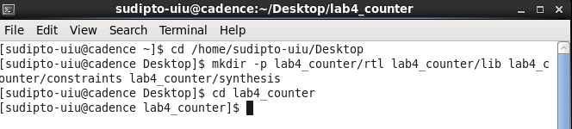
Figure-1.1. Terminal session creating the working folder and its sub-directories (reference screenshot from Experiment 6, shown as lab4_counter; lab7 was used for this experiment).
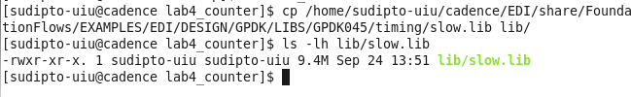
Figure-1.2. Copying slow.lib into lib/ and confirming the file with ls -lh (reference screenshot from Experiment 6).

1.4.2 Verilog RTL Description of the Adder
The adder was written in gedit and saved as Adder_32bit_8_stage.v. The module has clk, an active-low asynchronous rst, the 32-bit operands a and b and a carry-in cin as inputs, and the 32-bit sum and carry-out cout as outputs, with the parameters STAGES = 8 and WIDTH = 4. Four register arrays (a_pipe, b_pipe, sum_pipe and c_pipe) hold the operand bits, the accumulated sum and the running carry for each pipeline stage. A generate loop creates eight ADD_STAGE blocks; block g adds the 4-bit slice a_pipe[g][4g+3:4g] + b_pipe[g][4g+3:4g] + c_pipe[g], merges the resulting nibble into sum_pipe, and registers the new carry, while a negative edge of rst clears all registers. The final sum and cout are taken from the last stage. The complete source is given in Listing 1 and shown in Figure-1.3 and Figure-1.4.
`timescale 1ns/1ps

module Adder_32bit_8_stage (
input wire clk, input wire rst, input wire [31:0] a, input wire [31:0] b, input wire cin,
output wire [31:0] sum, output wire cout
);

localparam STAGES = 8;
localparam WIDTH = 4;

reg [31:0] a_pipe [0:STAGES]; reg [31:0] b_pipe [0:STAGES];
reg [31:0] sum_pipe [0:STAGES]; reg c_pipe [0:STAGES];

integer k;

always @(posedge clk or negedge rst) begin
if (!rst) begin
for (k = 0; k <= STAGES; k = k + 1) begin
a_pipe[k] <= 32'b0;
b_pipe[k] <= 32'b0;
sum_pipe[k] <= 32'b0;
c_pipe[k] <= 1'b0;
end
end else begin
a_pipe[0] <= a;
b_pipe[0] <= b;
sum_pipe[0] <= 32'b0;
c_pipe[0] <= cin;
end
end

genvar g;
generate
for (g = 0; g < STAGES; g = g + 1) begin : ADD_STAGE
wire [WIDTH-1:0] nibble_sum;
wire nibble_cout;

assign {nibble_cout, nibble_sum} = a_pipe[g][g*WIDTH +: WIDTH]
+ b_pipe[g][g*WIDTH +: WIDTH] + c_pipe[g];

always @(posedge clk or negedge rst) begin
if (!rst) begin
a_pipe[g+1] <= 32'b0;
b_pipe[g+1] <= 32'b0;
sum_pipe[g+1] <= 32'b0;
c_pipe[g+1] <= 1'b0;
end else begin
a_pipe[g+1] <= a_pipe[g];
b_pipe[g+1] <= b_pipe[g];
sum_pipe[g+1] <= sum_pipe[g] | (nibble_sum << (g*WIDTH));
c_pipe[g+1] <= nibble_cout;
end
end
end
endgenerate

assign sum = sum_pipe[STAGES];
assign cout = c_pipe[STAGES];

endmodule
Listing 1: Adder_32bit_8_stage.v - 8-stage pipelined 32-bit adder with active-low asynchronous reset. Each stage adds a 4-bit slice of a and b using the carry registered from the previous stage.
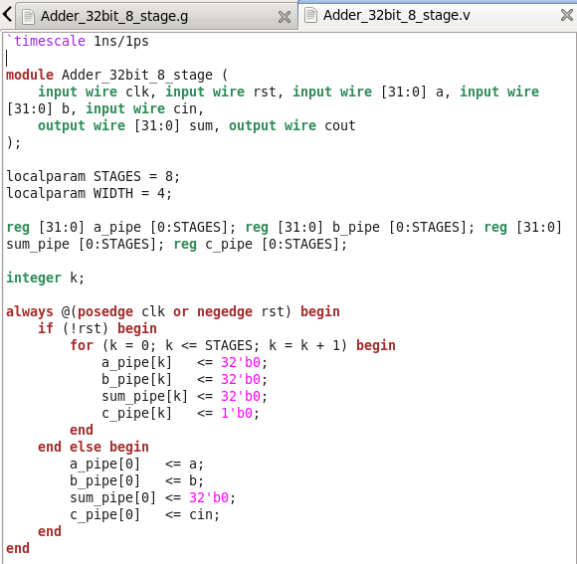  Figure-1.3. Adder_32bit_8_stage.v in gedit (part 1): module ports, parameters, pipeline registers and the reset/input-capture block. | 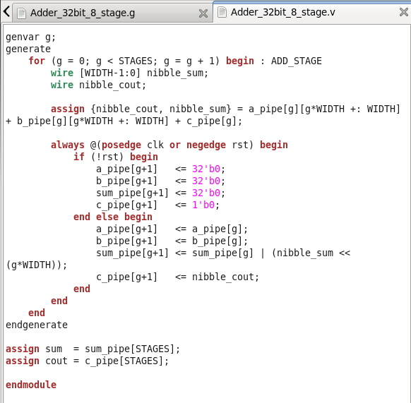  Figure-1.4. Adder_32bit_8_stage.v in gedit (part 2): the generate loop of eight 4-bit ADD_STAGE blocks and the output assignments.

1.4.3 Test Bench Description
A self-checking test bench, Adder_32bit_8_stage_tb.v (module Adder_32bit_8_stage_test), was written to exercise the adder. It instantiates the adder as uut and generates a free-running clock of period 10 ns (#5 clk = ~clk). Because the pipeline has a multi-cycle latency, the applied operands are also shifted through a reference chain of registers (a_q, b_q and c_q, nine stages deep); the value at the end of the chain is added with the + operator to form the expected result, which is compared with sum and cout on every clock edge once rst is HIGH, and any difference is printed as a MISMATCH message and counted in errors. The initial block holds rst LOW for 12 ns and then applies the six input vectors of Table-1.1 through the apply task, one per clock cycle, before waiting ten more clock edges and printing PASS or FAIL. The complete test bench is given in Listing 2 and shown in Figure-1.5 and Figure-1.6.
Table-1.1. Input vectors applied by the test bench, with the expected 32-bit result of each addition.
No. | a | b | cin | Expected sum | cout
1 | 00000000 | 00000000 | 0 | 00000000 | 0
2 | 00000001 | 00000001 | 0 | 00000002 | 0
3 | FFFFFFFF | 00000001 | 0 | 00000000 | 1
4 | FFFFFFFF | FFFFFFFF | 1 | FFFFFFFF | 1
5 | 12345678 | 87654321 | 0 | 99999999 | 0
6 | AAAAAAAA | 55555555 | 1 | 00000000 | 1

`timescale 1ns/1ps
module Adder_32bit_8_stage_test;

reg clk; reg rst; reg [31:0] a; reg [31:0] b; reg cin;
wire [31:0] sum; wire cout;

Adder_32bit_8_stage uut ( .clk(clk), .rst(rst), .a(a), .b(b), .cin(cin),
.sum(sum), .cout(cout) );
always begin
#5 clk = ~clk;
end

reg [31:0] a_q [0:8]; reg [31:0] b_q [0:8]; reg c_q [0:8]; integer k;
always @(posedge clk) begin
a_q[0] <= a; b_q[0] <= b; c_q[0] <= cin;
for (k = 0; k < 8; k = k + 1) begin
a_q[k+1] <= a_q[k];
b_q[k+1] <= b_q[k];
c_q[k+1] <= c_q[k];
end
end

reg [32:0] expected; integer errors;
task apply(input [31:0] ta, input [31:0] tb, input tc);
begin
@(posedge clk);
a = ta;
b = tb;
cin = tc;
end
endtask

initial begin
clk = 0; rst = 0; a = 0; b = 0; cin = 0; errors = 0; #12; rst = 1;
apply(32'h00000000, 32'h00000000, 1'b0);
apply(32'h00000001, 32'h00000001, 1'b0);
apply(32'hFFFFFFFF, 32'h00000001, 1'b0);
apply(32'hFFFFFFFF, 32'hFFFFFFFF, 1'b1);
apply(32'h12345678, 32'h87654321, 1'b0);
apply(32'hAAAAAAAA, 32'h55555555, 1'b1);
repeat (10) @(posedge clk);

if (errors == 0)
$display("PASS: all 32-bit additions matched across the 8-stage pipeline");
else
$display("FAIL: %0d mismatch(es) detected", errors);

$finish;
end

always @(posedge clk) begin
expected = a_q[8] + b_q[8] + c_q[8];
if (rst && (sum !== expected[31:0] || cout !== expected[32])) begin
$display("Time=%0t MISMATCH: a=%h b=%h cin=%b -> sum=%h cout=%b (expected sum=%h cout=%b)",
$time, a_q[8], b_q[8], c_q[8], sum, cout, expected[31:0], expected[32]);
errors = errors + 1;
end
end

endmodule
Listing 2: Adder_32bit_8_stage_tb.v - self-checking test bench with a 10 ns clock, a nine-stage reference chain, six input vectors and a PASS/FAIL report.
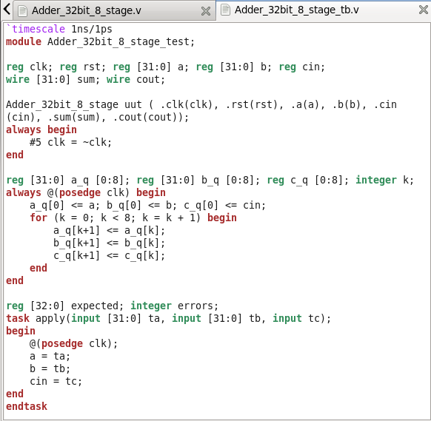  Figure-1.5. Adder_32bit_8_stage_tb.v in gedit (part 1): DUT instance, clock generator, reference chain and apply task. | 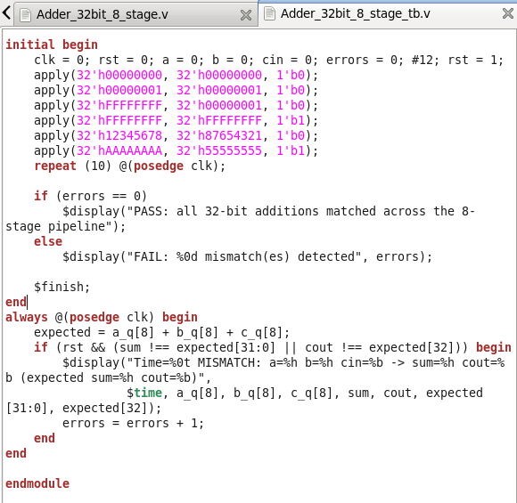  Figure-1.6. Adder_32bit_8_stage_tb.v in gedit (part 2): stimulus vectors, PASS/FAIL report and the mismatch checker.

1.4.4 Functional Verification using NCLaunch and IES
Both files were compiled and elaborated from NCLaunch (ncvlog, then ncelab) into the worklib library, and simulated with ncsim. Figure-1.7 shows the NCLaunch window with Adder_32bit_8_stage and Adder_32bit_8_stage_test both listed under worklib and a snapshot (worklib.Adder_32bit_8_stage_test:module) available to run, and the Command Entry Window reporting the ncelab completion followed by the ncsim launch, with no errors, confirming that the design compiled and elaborated successfully before simulation was started. Figure-1.8 shows the SimVision Design Browser and Console, listing a, a_q, b, b_q, c_q, cin, clk, cout, errors, expected, k, rst and sum for the test bench instance.
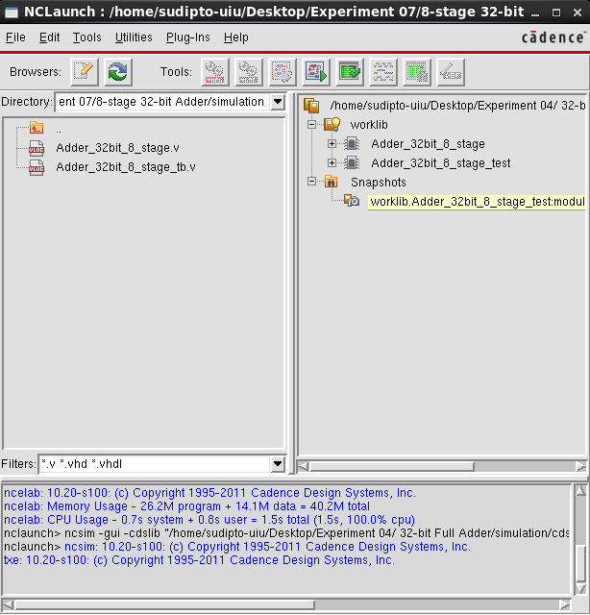  Figure-1.7. NCLaunch window showing Adder_32bit_8_stage and Adder_32bit_8_stage_test compiled and elaborated into worklib, with no errors in the Command Entry Window. | 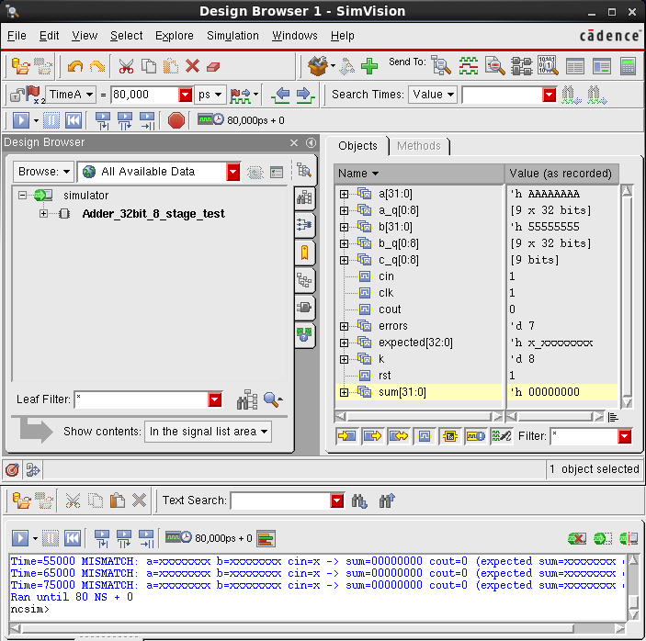  Figure-1.8. SimVision Design Browser and Console for Adder_32bit_8_stage_test at the 80 ns cursor, with the signal values and the $display log.

1.4.5 SimVision Waveform Analysis
The design was simulated with ncsim -gui and the waveforms were captured from 0 to 80 ns. Figure-1.9 shows all the relevant signals together: clk, rst, a, b, cin, sum, cout, errors and the internal signals of the test bench. The clk signal toggles every 5 ns, giving the expected 10 ns period. The rst signal is LOW for the first 12 ns and is then held HIGH. The input vectors of Table-1.1 appear on a, b and cin one clock period apart: a steps through 00000000, 00000001, FFFFFFFF, 12345678 and AAAAAAAA, b steps through 00000000, 00000001, FFFFFFFF, 87654321 and 55555555, and cin is HIGH for vectors 4 and 6.
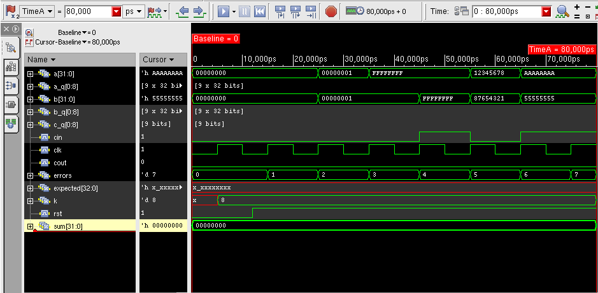
Figure-1.9. SimVision waveform for Adder_32bit_8_stage_test (0 to 80 ns), showing a, a_q, b, b_q, c_q, cin, clk, cout, errors, expected, k, rst and sum.
Figure-1.10 and Figure-1.12 expand the operands a and b into their individual bits, so that each vector can be traced bit by bit, and Figure-1.11 shows the reference-chain signals a_q, b_q and c_q.
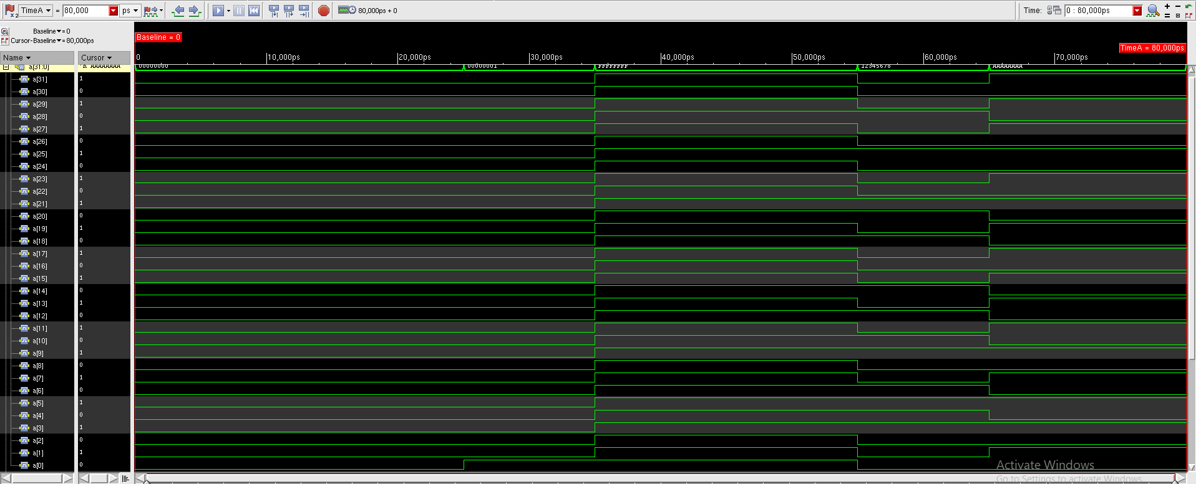
Figure-1.10. SimVision waveform showing the individual bits of input a[31:0] over the first 80 ns.
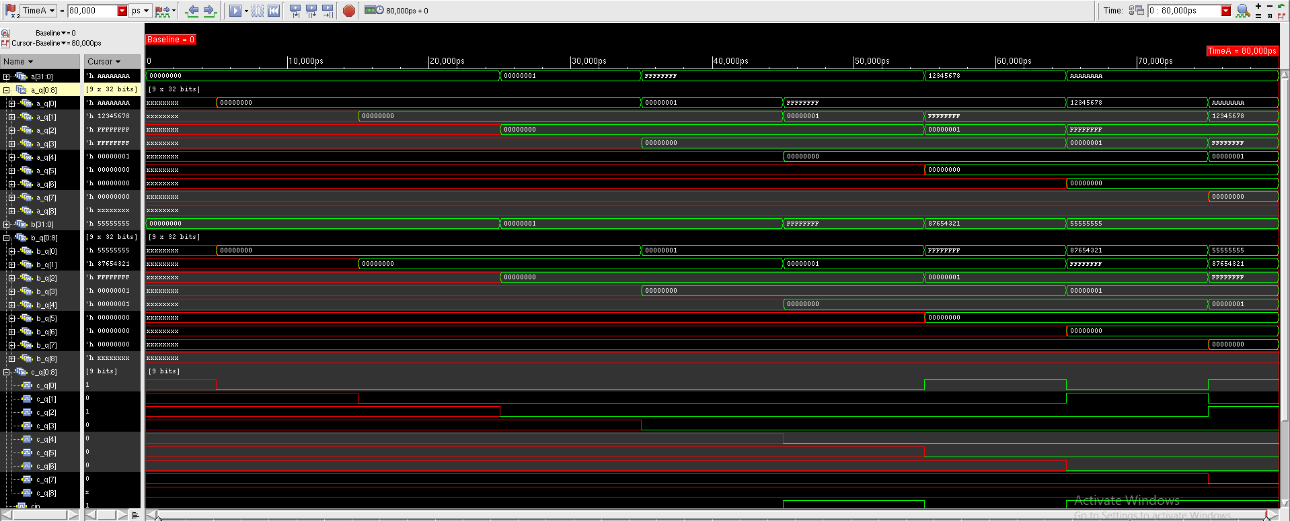
Figure-1.11. SimVision waveform showing the reference-chain signals a_q, b_q and c_q.
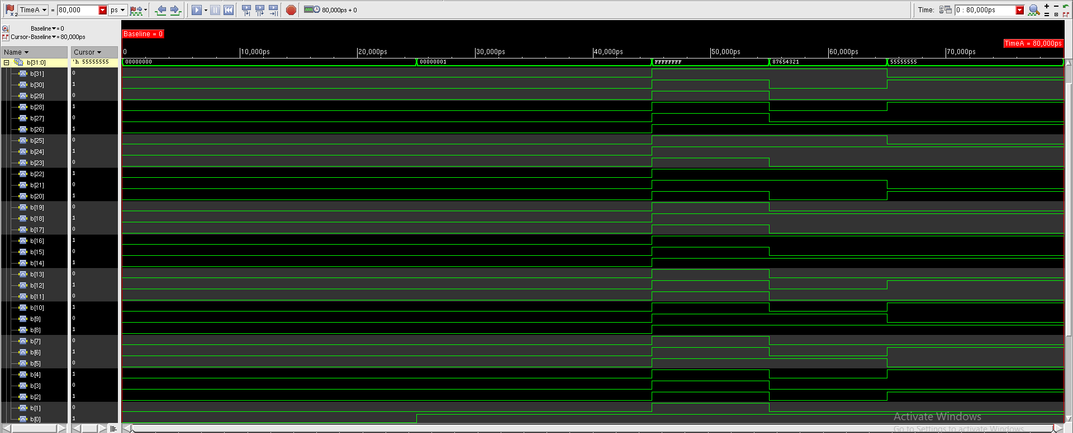
Figure-1.12. SimVision waveform showing the individual bits of input b[31:0] over the first 80 ns.

Figure-1.13 and Figure-1.14 show the error counter and the sum output. Within this 80 ns window, sum stays at 00000000 because the first operands have not yet reached the last pipeline stage: the pipeline latency of about 80 to 90 ns is longer than the window itself. The expected value is still unknown (x) for the same reason, since the nine-stage reference chain has no reset and needs nine clock edges to fill. The checker therefore reports a MISMATCH on each clock edge from 15 ns to 75 ns, which is why errors increments to 7 (the Console in Figure-1.8 shows the MISMATCH messages at 55, 65 and 75 ns, with the expected values printed as x). These early mismatches come from the unknown reference values, not from the adder itself; a meaningful comparison against the six expected results of Table-1.1 requires a longer run that passes the 90 ns fill time, so that the PASS/FAIL line is printed at $finish.
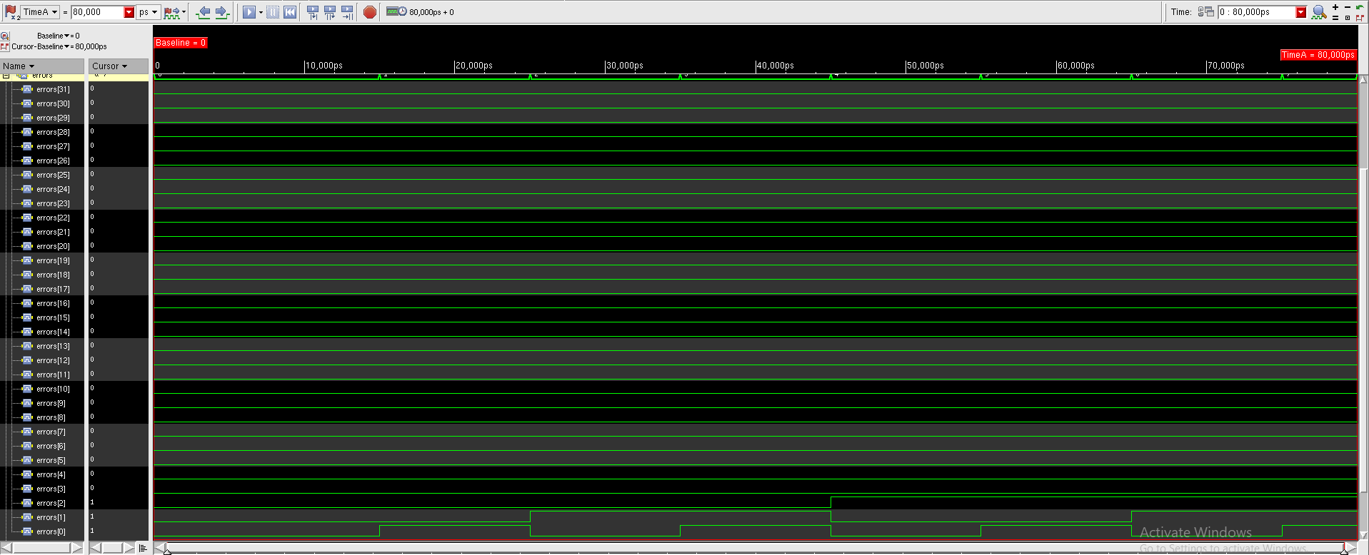
Figure-1.13. SimVision waveform showing the errors counter, which increments once per clock edge from 15 ns to 75 ns, reaching 7.
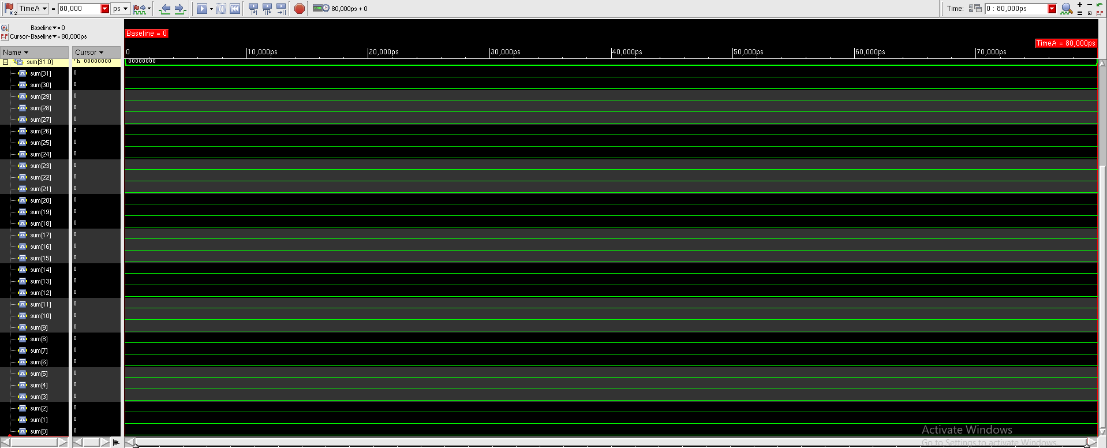
Figure-1.14. SimVision waveform showing the sum[31:0] output bits, held at 00000000 while the pipeline is still filling.

1.4.6 Timing Constraints (SDC)
A design constraint (SDC) file, Adder_32bit_8_stage.g, was written to guide synthesis. It defines a 10 ns clock named clk with a 0/5 ns waveform, sets a 0.1 ns clock transition on both edges and a 0.1 ns clock uncertainty, and sets a 1.0 ns maximum input delay on rst and a 1.0 ns maximum output delay on count, both relative to clk. The complete file is given in Listing 3 and is shown open in gedit in Figure-1.15.
create_clock -name clk -period 10 -waveform {0 5} [get_ports "clk"]
set_clock_transition -rise 0.1 [get_clocks "clk"]
set_clock_transition -fall 0.1 [get_clocks "clk"]
set_clock_uncertainty 0.1 [get_clocks "clk"]
set_input_delay -max 1.0 [get_ports "rst"] -clock [get_clocks "clk"]
set_output_delay -max 1.0 [get_ports "count"] -clock [get_clocks "clk"]
Listing 3: Adder_32bit_8_stage.g - a 10 ns clock definition, clock transition and uncertainty settings, and input/output delay constraints as used in this run.
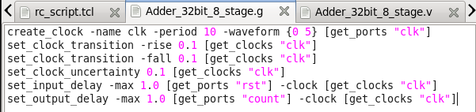
Figure-1.15. Adder_32bit_8_stage.g open in gedit, showing the clock definition and the I/O delay constraints.
Note: this constraint file was carried over from the counter of Experiment 6, so its I/O delays name the rst and count ports. The adder’s own data ports are a, b, cin, sum and cout; the Experiment 7 manual therefore specifies the two delay lines below for this design, in place of the rst and count lines of Listing 3.
set_input_delay -max 1.0 [get_ports {a[*] b[*] cin rst}] -clock [get_clocks "clk"]
set_output_delay -max 1.0 [get_ports {sum[*] cout}] -clock [get_clocks "clk"]

1.4.7 RTL Compiler Synthesis Script
The verified adder RTL was copied into the rtl directory as Adder_32bit_8_stage.v (cp simulation/Adder_32bit_8_stage.v rtl/), matching the naming used by the constraint file and by the RTL Compiler synthesis script, rc_script.tcl. The script sets the library and search paths, reads and elaborates Adder_32bit_8_stage.v with the -v2001 option (which selects Verilog-2001 ANSI-style port declarations), reads in the SDC constraints, synthesizes the design to a mapped netlist at medium effort, reports timing and power, and finally writes out the gate-level netlist and the post-synthesis SDC. The script is given in Listing 4 and shown open in gedit in Figure-1.16.
set_attr lib_search_path ../lib/
set_attr hdl_search_path ../rtl/
set_attr library slow.lib

read_hdl -v2001 Adder_32bit_8_stage.v
elaborate Adder_32bit_8_stage
read_sdc ../constraints/Adder_32bit_8_stage.g

synthesize -to_mapped -effort medium

report timing
report power

write_hdl > Adder_32bit_8_stage_netlist.v
write_sdc > Adder_32bit_8_stage.sdc
Listing 4: rc_script.tcl - sets the library and search paths, reads and elaborates the RTL, reads the SDC constraints, synthesizes to a mapped netlist, reports timing and power, and writes out the netlist and SDC.
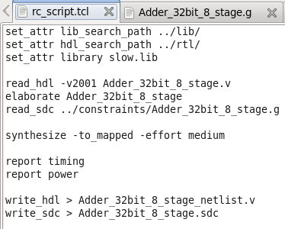
Figure-1.16. rc_script.tcl open in gedit, showing the complete synthesis script.

1.4.8 Pre-Synthesis File Verification
Before invoking RTL Compiler, the four required files were confirmed to be in place from the working directory using ls -lh: rtl/Adder_32bit_8_stage.v, lib/slow.lib, constraints/Adder_32bit_8_stage.g and synthesis/rc_script.tcl, as shown in Figure-1.17.
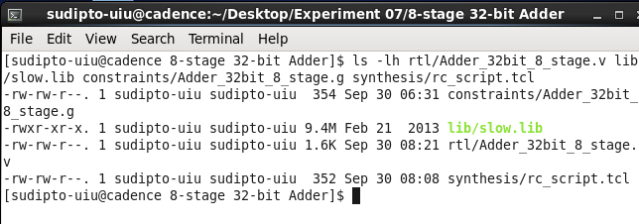
Figure-1.17. ls -lh confirming that Adder_32bit_8_stage.v, slow.lib, Adder_32bit_8_stage.g and rc_script.tcl are all present before synthesis.

1.4.9 Running Synthesis: RTL Compiler Output
RTL Compiler was invoked from the synthesis directory with rc -f rc_script.tcl. Figure-1.18 shows the rc terminal output at the end of synthesis. During optimization, RTL Compiler replaced several flip-flops with a logic constant 0 (message GLO-12, for example on sum_pipe_reg[2][16], [14], [10], [17] and [28]) and deleted 24 sequential instances that did not drive any primary output (GLO-32). This is expected for this architecture: sum_pipe at pipeline stage k can only be non-zero in its lower 4k bits, so the upper bits of the early sum registers are constant 0 and need no flip-flop. The incremental optimization tables then report no remaining violations, and the log ends with “Done mapping Adder_32bit_8_stage” and “Synthesis succeeded.” The timing and power reports that follow in the terminal are produced by the report timing and report power commands of the script. The key outcomes are summarised in Table-1.2.
Table-1.2. Key synthesis results for the mapped Adder_32bit_8_stage design (gpdk045 slow.lib). Highlighted cells are to be filled from the report timing and report power output of the run.
Parameter | Value
Technology library | gpdk045 slow.lib (slow corner, balanced_tree)
Clock constraint | 10 ns period, 0.1 ns uncertainty
Synthesis command | synthesize -to_mapped -effort medium
Synthesis status | Done mapping Adder_32bit_8_stage; Synthesis succeeded
Flip-flops replaced by constant 0 | Reported by GLO-12 (e.g. sum_pipe_reg[2][16])
Sequential instances deleted | 24 (GLO-32)
Critical path / timing slack | ~7760 ps (from report timing)
Leakage / Dynamic / Total power | ~695 / ~2542583 / ~2543278 nW (from report power)
Instance cells | ~296 (from report power)

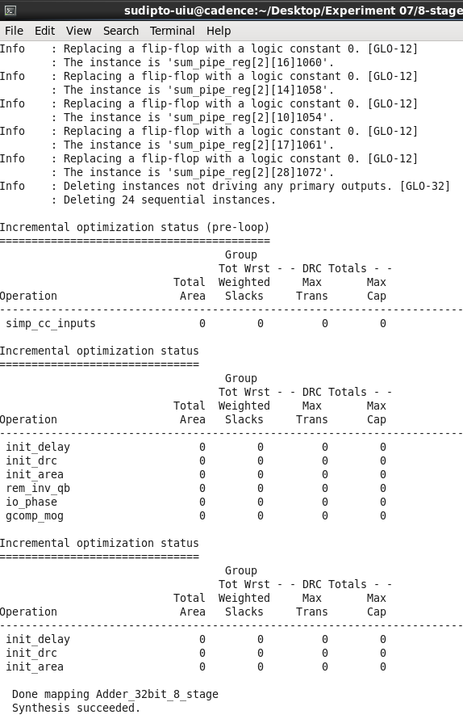
Figure-1.18. rc terminal output at the end of synthesis, showing the optimization log, the completion of technology mapping and the confirmation that synthesis succeeded.

1.4.10 Synthesized Gate-Level Schematic
After synthesis, the mapped schematic was opened with gui_show from the rc prompt. Figure-1.19 shows four consecutive views of the schematic of the synthesized 8-stage pipelined adder. The design is dominated by wide banks of flip-flops (the small boxes at the right of each view), with the operand, sum and carry wires running between them, and a repeated pattern of adder and logic cells at the bottom of the schematic that corresponds to the eight 4-bit addition stages. The repeated ripple-and-register structure across the width of the schematic therefore matches the register-and-adder-slice organization of the RTL described in Section 1.4.2.
Figure-1.19(a). RTL Compiler schematic of the synthesized adder, part 1.  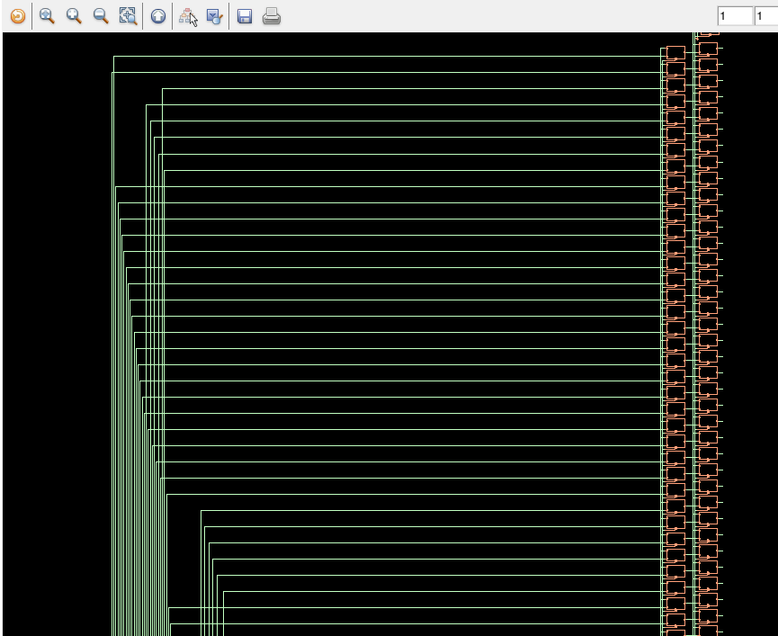 | Figure-1.19(c). RTL Compiler schematic of the synthesized adder, part 3.  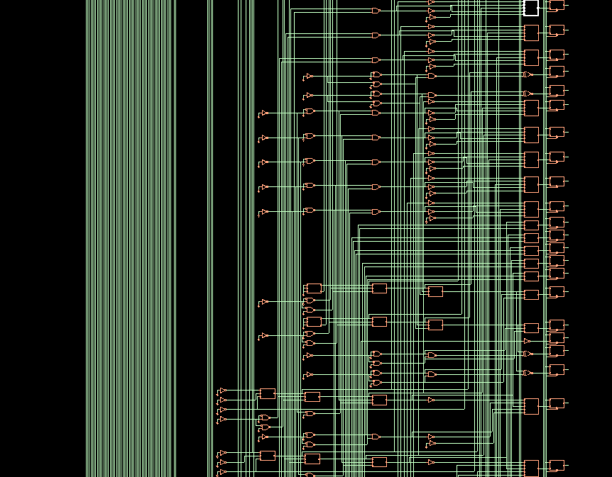
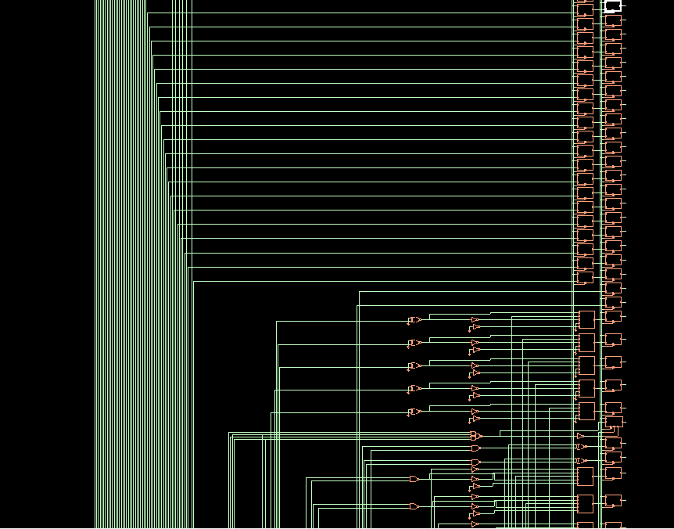  Figure-1.19(b). RTL Compiler schematic of the synthesized adder, part 2. | 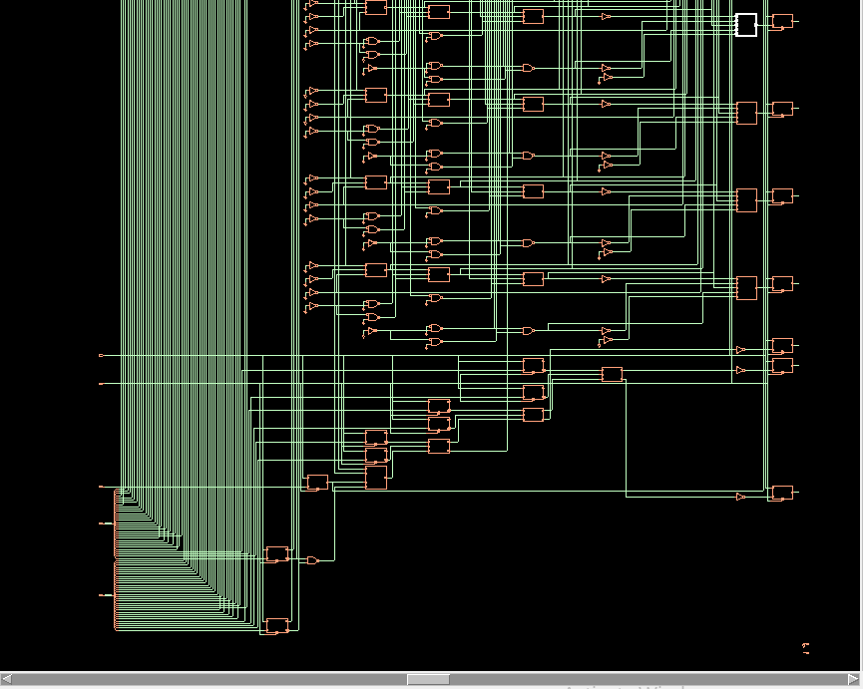  Figure-1.19(d). RTL Compiler schematic of the synthesized adder, part 4.

1.5 Discussion
Two operating modes of the pipelined adder were observed in simulation. In the asynchronous reset mode, rst LOW clears every pipeline register at once, so sum and cout stay at zero regardless of clk, as seen up to 12 ns. Once rst goes HIGH, the adder enters its pipelined addition mode: on every rising edge each stage adds one 4-bit slice of a and b with the carry from the previous stage and passes the partial sum forward, so a result appears only after the operands have travelled through all the stages. In the 0 to 80 ns waveform window, sum therefore remains 00000000 even though all six input vectors have been applied, because no result has yet reached the last stage. The seven counts in errors match the seven clock edges between 15 ns and 75 ns, when the reference chain in the test bench still held unknown values. The synthesized schematic shows the same register-and-adder structure as the RTL, and RTL Compiler reported that synthesis succeeded, after pruning flip-flops that were constant 0.

1.5.1 The Cost and Benefit of Pipelining
The pipelined adder should be compared, in cell count, area and power, with an unpipelined (behavioral, single-cycle) 32-bit adder synthesized under the same slow.lib library and the same 10 ns clock constraint. The pipelined design uses substantially more flip-flops, because the operand bits, the 32 sum bits and a running carry are re-registered at every one of the eight stages, so its cell count, area and dynamic power will generally be higher than those of a purely combinational adder. The synthesis log in Figure-1.18 shows that RTL Compiler already removes the registers that are provably constant (the upper sum bits of the early stages) and the sequential instances that never reach an output, so the mapped flip-flop count is lower than the nominal count implied by the RTL, but it remains far above the zero flip-flops of a combinational adder.
In exchange, the combinational path within any single clock cycle is only as long as a 4-bit ripple-carry addition, so the pipelined design should comfortably meet a much tighter clock period than the unpipelined version could. The timing slack printed by report timing (Table-1.2) is one indication of how much margin remains at the constrained 10 ns period. The other cost is latency: the full 32-bit sum is available only after the operands have passed through the pipeline, which is why sum was still 00000000 in the 80 ns waveform window.

1.6 Conclusion
In this experiment, an 8-stage pipelined 32-bit adder with active-low asynchronous reset was written in Verilog, compiled and elaborated without errors through NCLaunch/IES, and simulated in SimVision, where the reset behaviour, the clock, the input vectors and the pipeline-fill delay were observed on the waveform. The pre-synthesis file check, the SDC timing constraints and the rc_script.tcl synthesis script together took the design through the complete standard-cell flow with Cadence RTL Compiler against the gpdk045 slow-corner library, producing a mapped gate-level netlist (after RTL Compiler pruned constant and unused registers) and reporting “Synthesis succeeded.” The synthesized schematic showed the repeated register-and-adder structure of the eight 4-bit stages. The discussion of pipelining showed that the technique trades additional flip-flops, area, power and latency for a much shorter combinational path per clock cycle. This experiment provided practical, hands-on experience with the standard-cell synthesis flow that forms the basis for physical design in subsequent experiments.

